Epiphone:
‘Joe Bonamassa Lazarus 1959 Les Paul Standard’
Available Worldwide on Epiphone.com

Blues-Rock Guitar Legend Teams with Gibson to Re-create a Rare and Fully--Restored 1959 Gibson Les Paul Guitar
New Album ‘Time Clocks’ Due Out October 29

All Epiphone Joe Bonamassa Lazarus 1959 Les Paul Standard photos: HERE.
Watch and share the Joe Bonamassa interview as he tells the story behind the Lazarus Les Paul guitar on Epiphone: HERE and Gibson TV: HERE.

NASHVILLE, TN (October 7, 2021) Epiphone, the accessible brand for every stage, presents the new Epiphone Joe Bonamassa Lazarus 1959 Les Paul Standard, now available worldwide. As the ninth signature guitar from the pre-eminent blues guitarist of his generation, Joe Bonamassa and Epiphone collaborated to bring to life the Lazarus guitar, which was based off one of Joe’s most-rare finds, a 1959 Les Paul Standard that needed a full restoration. The Epiphone Joe Bonamassa Lazarus 1959 Les Paul Standard is officially available worldwide at all authorized Epiphone dealers and on www.epiphone.com.

“We wanted to make a model that was accessible to everyone at a price point that you could buy it and go out and gig with it; it looks and feels like the original guitar,” says Joe Bonamassa. “It’s gig-ready, and it’s a great tool to have whether you’re playing out live, in the studio, or just having fun at home annoying your neighbors.”

“Joe Bonamassa is a custodian of Gibson by virtue of having put together one of the most epic guitar collections in the world, as a musician and guitarist he continues to inspire fans to pick up a guitar and play,” says Cesar Gueikian, Brand President, Gibson Brands. “The Epiphone Lazarus 1959 Burst is a re-creation of Joe’s storied 1959 Gibson Lazarus Burst, which was once hiding under a thick red coat of paint and was brought back to its original finish thanks to Joe. Today, Lazarus travels with Joe and is seen on stages all over the globe. The story of Lazarus is one worth checking out and we hope this Epiphone creation inspires players of all levels.”

Watch and share the new Joe Bonamassa interview where Joe tells the full story of the discovery of Lazarus and the complete restoration journey of the guitar, HERE.

Watch and share the Joe Bonamassa interview as he tells the story behind the Lazarus Les Paul on Epiphone: HERE and Gibson TV: HERE.

As the story goes, a red, dinged-up Les Paul was brought to Joe’s table at Barone’s in Hollywood, which in turn launched an impromptu investigation into the true origin of the guitar in question. Kim LaFleur, of Historic Makeovers, confirmed Joe’s suspicions that the guitar was indeed a 1959 Les Paul Standard. Joe was ecstatic and so moved by this stroke of good fortune that he named the guitar “Lazarus.” Much like Lazarus of the Bible, this ’59 Les Paul literally came back from the dead, and once restored, the guitar’s stunningly figured top was revealed. Not wanting that to be the end of the story, Joe teamed up with Epiphone to honor this great guitar with an artist model aptly named the Epiphone Joe Bonamassa “Lazarus” 1959 Les Paul Standard. The Epiphone Joe Bonamassa Lazarus 1959 Les Paul Standard is the first Epiphone model to include a One-Piece Mahogany Neck. Lazarus also features a mahogany body with a maple cap that is topped with a wide-grain AAAA flame maple veneer. The sweet tone comes from some of Joe’s favorite pickups; Gibson BurstBuckers paired with 50s style wiring and CTS® potentiometers and Mallory™ capacitors. The Lazarus comes with a vintage-style case sporting Bonamassa graphics and a certificate of authenticity.
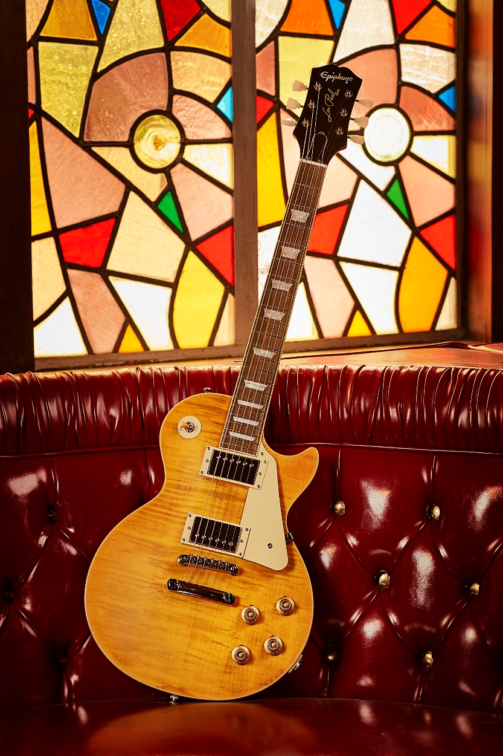
Above: Epiphone Joe Bonamassa Lazarus 1959 Les Paul Standard.

The two-time GRAMMY-nominated artist with 24 #1 albums on the Billboard Blues Chart,
blues-rock superstar Joe Bonamassa will release his new album Time Clocks on October 29: https://shop.jbonamassa.com/collections/time-clocks. Recorded in New York City, Time Clocks rediscovers Joe Bonamassa at a newfound peak with heartfelt songwriting and unparalleled blues rock prowess. For the album, Joe hit the studio with longtime collaborators Kevin Shirley as producer and manager/business partner Roy Weisman as executive producer. The album was recorded in New York City at Germano Studios/The Hit Factory and mixed by Bob Clearmountain (Bruce Springsteen, The Rolling Stones, Toto, Bon Jovi). Time Clocks features the recent singles “Notches” and the next Blues-heavy single “The Heart That Never Waits". Joe Bonamassa and his band will hit the road this Fall for a tour. For all Joe Bonamassa tour dates, visit: here.
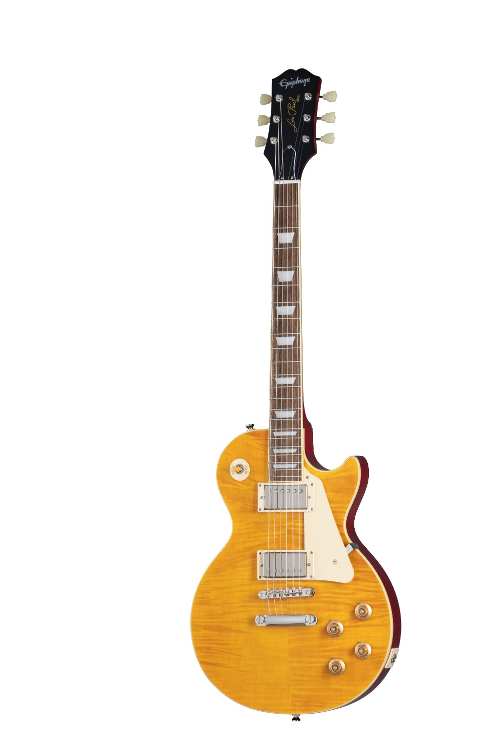
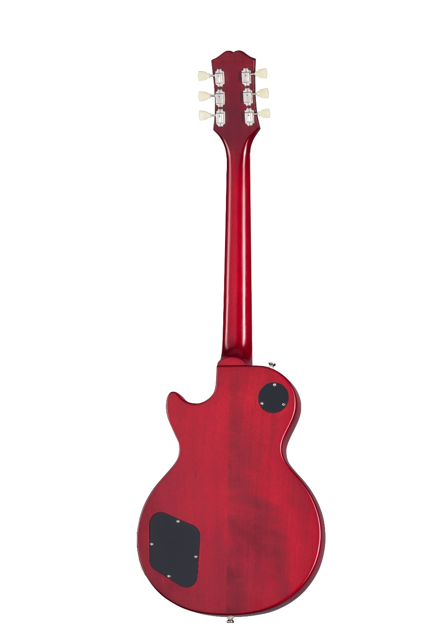
Above: the Epiphone Joe Bonamassa Lazarus 1959 Les Paul Standard.

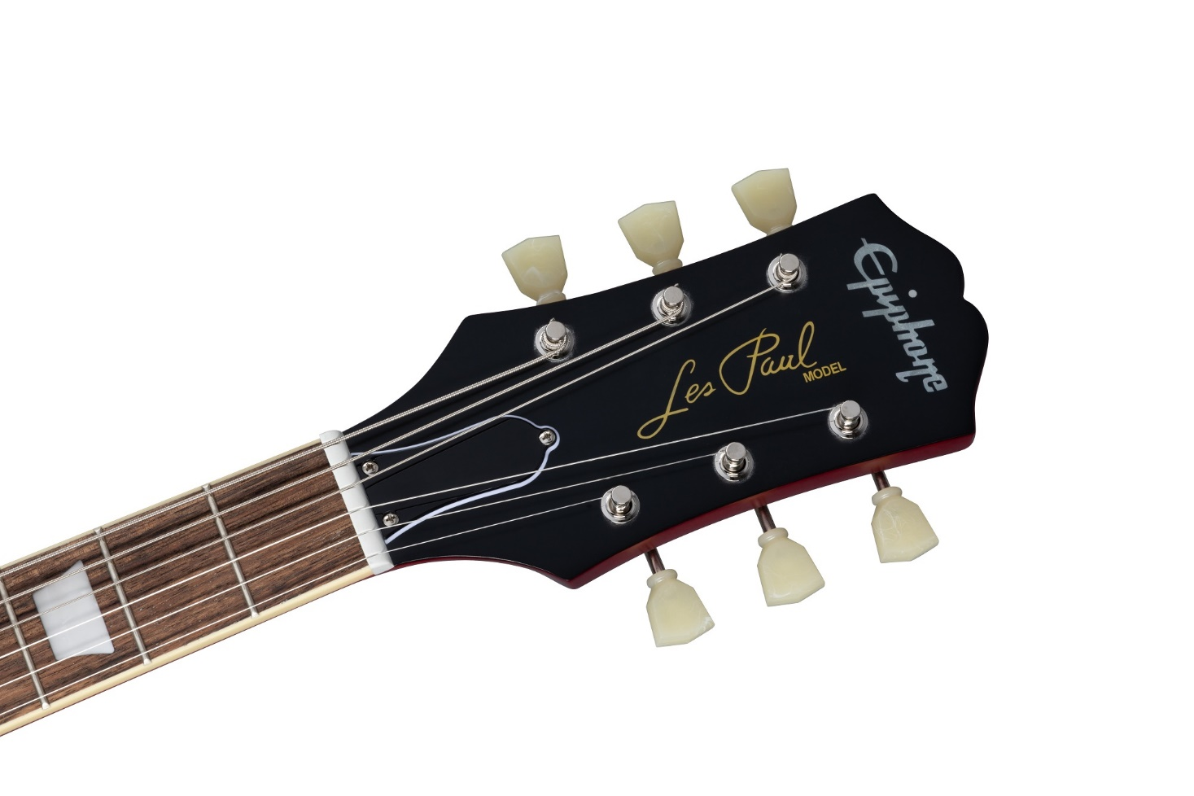
Above: the Epiphone Joe Bonamassa Lazarus 1959 Les Paul Standard headstock.

Joe Bonamassa:
JBONAMASSA.COM | FACEBOOK | TWITTER | INSTAGRAM
Epiphone:
EPIPHONE.COM | TWITTER | INSTAGRAM | FACEBOOK | YOUTUBE
Gibson:
GIBSON.COM | FACEBOOK | TWITTER | INSTAGRAM | GIBSON TV
Kramer:
KRAMERGUITARS.COM | TWITTER | INSTAGRAM | FACEBOOK | YOUTUBE
MESA/Boogie:
MESA/BOOGIE.COM | TWITTER | INSTAGRAM | FACEBOOK
KRK:
KRKMUSIC.COM | TWITTER | INSTAGRAM | FACEBOOK | YOUTUBE

About Joe Bonamassa:
Blues-rock superstar Joe Bonamassa is one of the most celebrated performing musicians today. As a two-time GRAMMY-nominated artist who recently achieved his 24th #1 album on the Billboard Blues Chart (more than any other artist) with his last album Royal Tea, Joe is only in his early 40s and he's already become a living legend with an astounding multi-genre catalogue of music. Joe's highly anticipated new studio album Time Clocks is set to release on October 29th. Collectively, Bonamassa has over 40 albums to date, all on his own label J&R Adventures, including studio and live recordings, collaborative albums and adventurous side projects. A prolific writer who is always on the hunt to expand his eclectic musical horizons, Bonamassa has a limitless work ethic whether it's in a studio, on the road, producing, or working with other artists to spur new music.
In addition to his music and shows, Joe continues to crank out weekly programming for his radio show “Different Shades Of Blue” for Sirius XM’s Bluesville channel. Last year, he kicked off a new at-home weekly video interview series “Live From Nerdville” which currently has over 60 episodes aired on his Facebook, YouTube, and podcast outlets. With a new episode each week, Joe has featured conversations with Neal Schon of Journey, John Oates of Hall & Oates, Glenn Hughes, Paul Stanley of Kiss, Warren Haynes, Keb’ Mo’, Walter Trout, Steve Lukather of Toto, Todd Rundgren, comedian Jeff Garlin, esteemed singer-songwriter Dion, Peter Frampton, Brad Paisley and many more.
Last summer, Bonamassa and his manager Roy Weisman debuted their new record label Keeping The Blues Alive Records by releasing music icon Dion’s critically acclaimed latest album Blues With Friends. In February 2021, KTBA Records released Chicago’s reigning Queen of Blues Guitar, Joanna Connor’s new album 4801 South Indiana Avenue, which debuted at #1 on the Billboard Blues chart. Earlier this month KTBA Records released Joanne Shaw Taylor’s highly acclaimed The Blues Album on Sept 24th. Dion has just announced his own upcoming album Stomping Ground releasing on November 5th, 2021. Stay tuned for future releases at ktbarecords.com.

About Epiphone:
For over 140 years, Epiphone has been a leading innovator in instrument design with models like the Casino, the Texan, and Masterbilt Century Archtop Collection. Epiphone began as the "House of Stathopoulo" family business in Sparta in the 1870s and rose to fame during the jazz age in Manhattan before joining Gibson brands in 1957. Today, Epiphone continues to make history from its headquarters in Nashville, TN. Epiphones have powered classic recordings by Les Paul, The Beatles, and The Rolling Stones along with today's top artists like Peter Frampton, Gary Clark Jr., Tommy Thayer of KISS, and Lzzy Hale. Epiphone offers innovation, history, and a lifetime guarantee. Whether you are learning your first song in your bedroom, or rocking an arena, Epiphone has always been there, for everyone, for every generation, for every stage. For more information, visit: Epiphone.com and follow us on Twitter, Facebook, YouTube, and Instagram.

###
For media enquiries regarding Epiphone contact:

PRIME PR GROUP, INC.
Libby Coffey
+1 626-676-4993
LCoffey@primeprgroup.com

